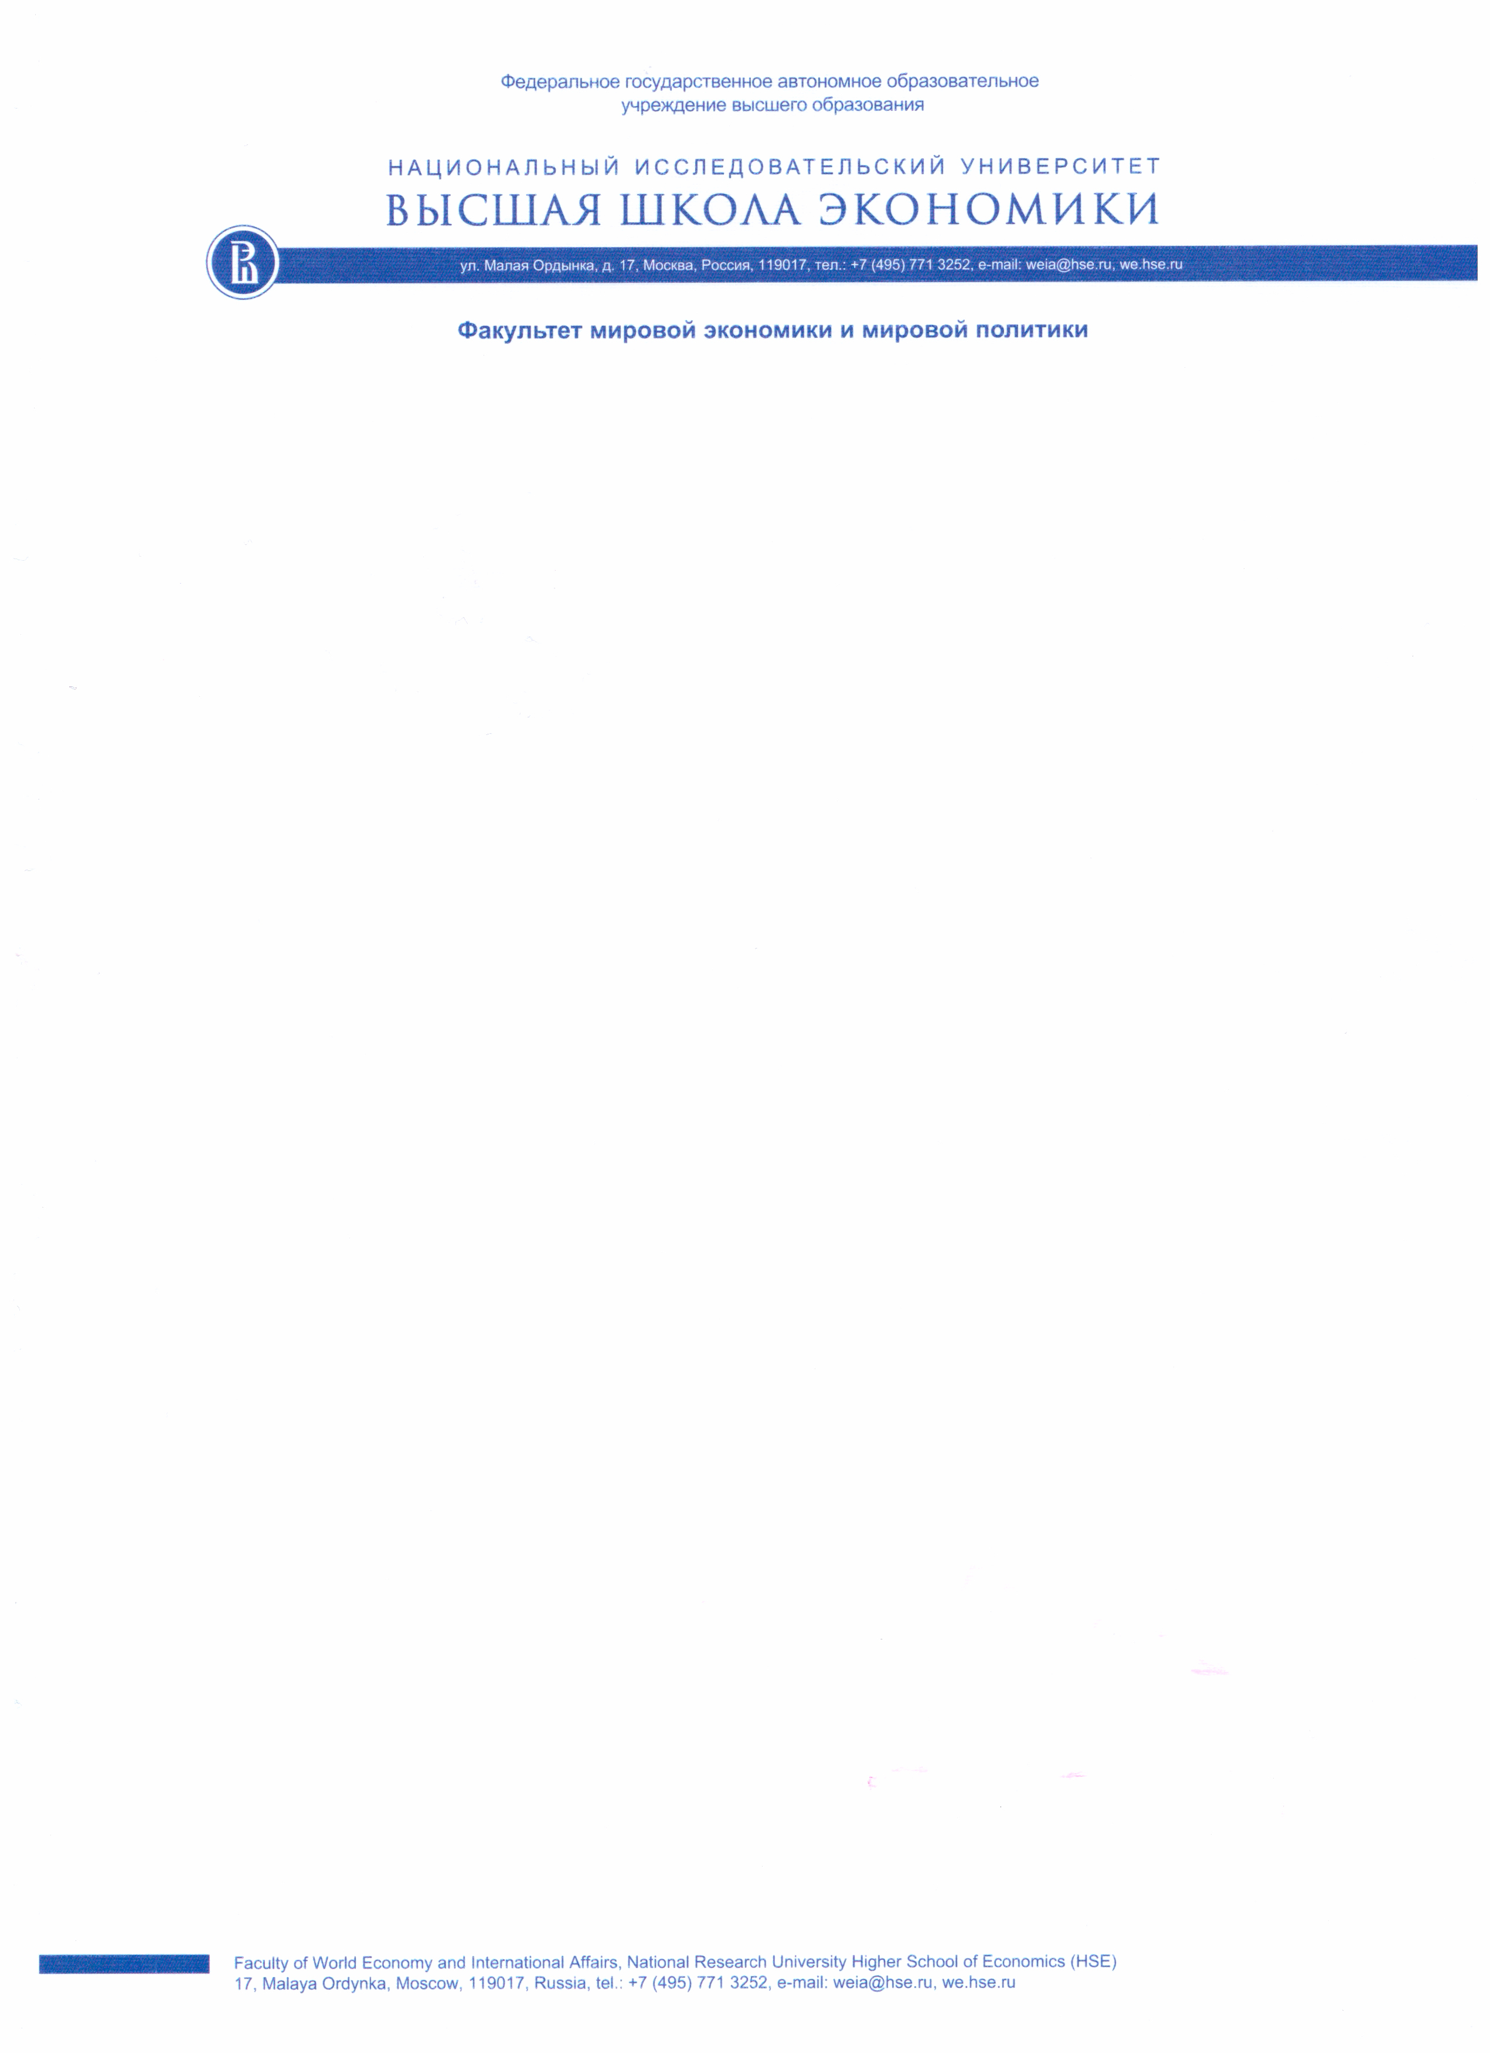

ANEX II. SUBMISSION GUIDELINES

National Research University «Higher School of Economics»
Faculty of World Economy and International Affairs

The 2nd International Conference
"EAST AND WEST IN THE NEW TRANSFORMATION PHASE:
ASIA ENCOUNTERING THE CHALLENGES OF DEGLOBALIZATION"
December 16th – 17th, 2020
Moscow, the Russian Federation

- The Manuscript Submission: Basic Formatting and Provisions

Basic formatting. The text is to be submitted in English, up to 20 thousand letters with spaces, font Times New Roman, size 12, abstracts - size 10, line spacing 1.5, illustrations – 190 × 270 mm or 6.7 thousand characters. Articles exceeding the indicated volume are not allowed for publication.
By submitting the manuscript to the editorial board, the author confirms the transfer of authority for publication, reproduction, distribution, posting in the Internet, public display, as well as translation into foreign languages, in accordance with and subject to the terms and conditions of the law.

- The Text Guidelines

The manuscript is to be supplemented by:
1) the information about the academic degree, the academic rank, the position and the affiliation;
2) the phone number, the email and the postal addresses of the author.

The chapter is to be supplemented by up to five keywords (no more than 5) and the summary (240-270 words, but up to 1,800 characters with spaces).

The submitted chapters are to be supplemented by the List of References (at least 10-15 publications, including the Internet sources). The references are to be placed in the alphabetical order (first a block of publications in Russian, then in European and finally in Eastern languages). The references are not to be numbered.

The bibliographic description of the used materials includes the names and the initials of the authors (for the Eastern authors, the family name and the personal name), the full title of the material and the journal in which it was published (for articles), the city, the name of the publishing house or publishing organization, the publication year, the volume (for multi-volume editions), the number, the issue (for periodicals), the publication volume (number of pages for a monograph, the first and the last page for an article). Each item in the bibliography is to be accompanied by references.

The text of the article should be structured into sections: introduction, methodology, main results, conclusion. Texts with random structures will not be accepted.

- Examples of the Sources Cited

Kakar H. The Fall of the Afghan monarchy in 1973 // Int. J. of Middle Eastern Studies, 1978. Vol. 9. No. 2. P. 195–214. (in English).
Guksa pyeonchan wiwonhoe. Geundaewa mannan misulgwa dosi [근대와 만난 미술과 도시. 서울: 두산동아]. City and art on the threshold of modernity. Seoul: Dusantonga, 2008. 352 p. (in Kor.)
Kireeva L. I. About study of artistic value of Korean art in Western countries // Proceedings of the Center for Korean language and culture. S.-Petersburg, 2005. P. 187–191. (in Russ.)
Sokolov K. B. Artistic life of the modern society. Subcultures and ethnic groups in artistic life. Saint-Petersburg, 1996. Vol. 1. 237 p. (in Russ.)
Tikhonov V. M., Kang Mangil. History of Korea. Vol. 1: from the earliest times to 1904. Moscow: Natalis, 2011. 533 p. (in Russ.)
Links to archival documents, as well as to sources and papers published on the Internet and not amenable to bibliographic description, are to be made in the form of footnotes at the bottom of every page. Illustrations (drawings, photographs) are to be submitted in .jpg, .tif, .cdr formats. It is allowed to submit tables and diagrams in Excel program (by saving the source file in .xls format), to attach the files of the used (non-standard) fonts (.ttf), the size of the font in the inscriptions (only Arial) are not be less than 9. Comments to the illustrations and tables are to be made in English.

- The Content Guidelines

The chapters and the summaries are submitted in English. For quotations and terms in Oriental languages, the following rules are to be followed: Chinese - pinyin, SimSun font; Japanese - romaji, font MS Mincho; Korean - "New Romanization of the Korean language" (2000), font Gulim. The List of References at the end of the chapter is to indicate the language in which the publication was made: (in Russian / Chinese / Japanese / Korean) and (in Russ./Chin./Jap./ Kor.).
The submission of previously published articles, as well as manuscripts compiled from previously published scientific papers to the editorial office, is forbidden. The Editorial Board is authorized to edit, reduce (as agreed with the author) and accept the published materials at its own discretion.

- Deadlines

Full texts should be submitted before 17 January 2021 to the email address - irs@hse.ru.
Materials sent after this date will not be accepted.

There is no fee for publishing.

