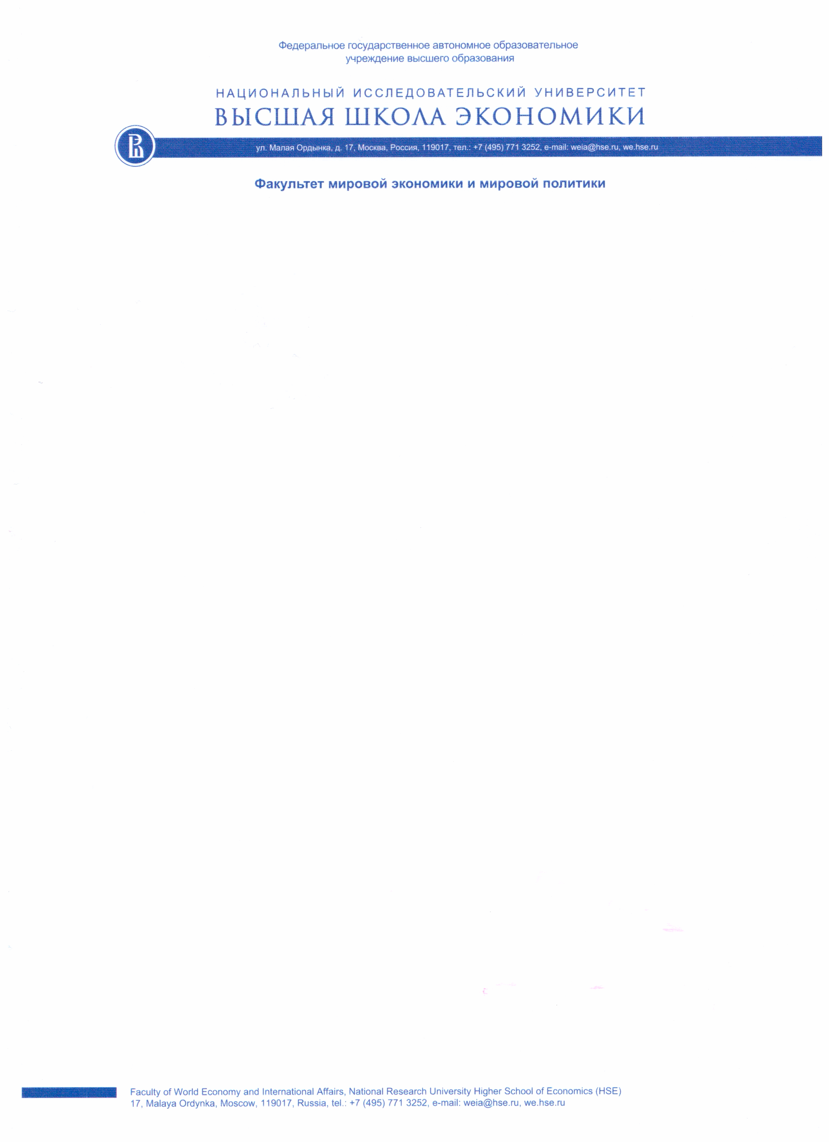

ANNEX 1. ABSTRACT
The 2nd International Conference
"EAST AND WEST IN THE NEW TRANSFORMATION PHASE:
ASIA ENCOUNTERING THE CHALLENGES OF DEGLOBALIZATION"
December 16th – 17th, 2020
Moscow, Russian Federation

Full Name in English
Place of work, Status
Research Topic in English
Which section do you prefer to participate in? | - Day 1. Plenary Session "The Rise of Asia” as a Long-Term Trend: the Degree of Sustainability"  - Day 1. Section 1 "The Asian Century" - Chimera or Reality: a New Configuration of Power between West and East"  - Day 2. Round Table "How Different Countries Tackled Crises: Lessons from the Past"  - Day 2. The Youth Section of the Conference "The Role of Regional Powers in Resolving Crises in the East"
Abstract in English (Guidelines for abstracts: 500 to 800 words in English. Abstracts are to be attached to the application form during the online registration.)

